National Gateway Infrastructure (NGI)

Interface Design Document
NGI NPRA Online Visa Services

Document Control
Amendment History:
S. No. | Authors (s) | Version | Date | Change Description
1. | Sudhakar M | 1.0 | 15-May-2020 | Initial Draft.

Reviewers:
S. No. | Name | Position | Version
 | Thiyaneshwaran R | Technical Lead | 1.0

Table of Contents
1. Definition, Acronyms and Abbreviations 4
2. Service Properties 4
2.1 Business Properties 4
2.2 Operations & Properties 5
2.3 Technical Properties 6
2.3.1 LKUPServiceType 6
2.3.2 LKUPApplicantType 6
2.3.3 LKUPNationalityList 7
2.3.4 LKUPGCCCountryList 8
2.3.5 LKUPSponsorIdentityTypes 8
2.3.6 ValidateEKeyApplicantEligibility 9
2.3.7 ValidateVisaDetails 10
2.3.8 UploadVisaAttachment 12
2.3.9 SubmitVisaExtend 13
2.3.10 GetRequestsList 15
2.3.11 GetRequestDetailsByRequestNumber 17
2.3.12 GetVisasList 18
2.3.13 DownloadVisa 20
2.4 Business Flow Usage 21
2.5 Message Definition 21
2.6 Error Code and Error Message 22
2.7 Security 23
2.7.1 Sample SOAP1.1 Header 23

Definition, Acronyms and Abbreviations
IGA | Information & eGovernment Authority
NGI | National Gateway Infrastructure
CIO | Central Informatics Organization
B2B | Business To Business
NPRA | Nationality Passport and Residence Affairs

Service Properties

Business Properties
Service | Service ID/Code | Description | Status | Associations
 |  |  |  | Function/ process | Goal
NGI_NPRAOnlineVisaServices | NPRAOVR | - LKUPServiceType  - LKUPApplicantType  - LKUPNationalityList  - LKUPGCCCountryList  - LKUPSponsorIdentityTypes  - ValidateEKeyApplicantEligibility  - ValidateVisaDetails  - UploadVisaAttachment  - SubmitVisaExtend  - GetRequestsList  - GetRequestDetailsByRequestNumber  - GetVisasList  - DownloadVisa | -- | This service is exposed on NGI layer. | -

Operations & Properties
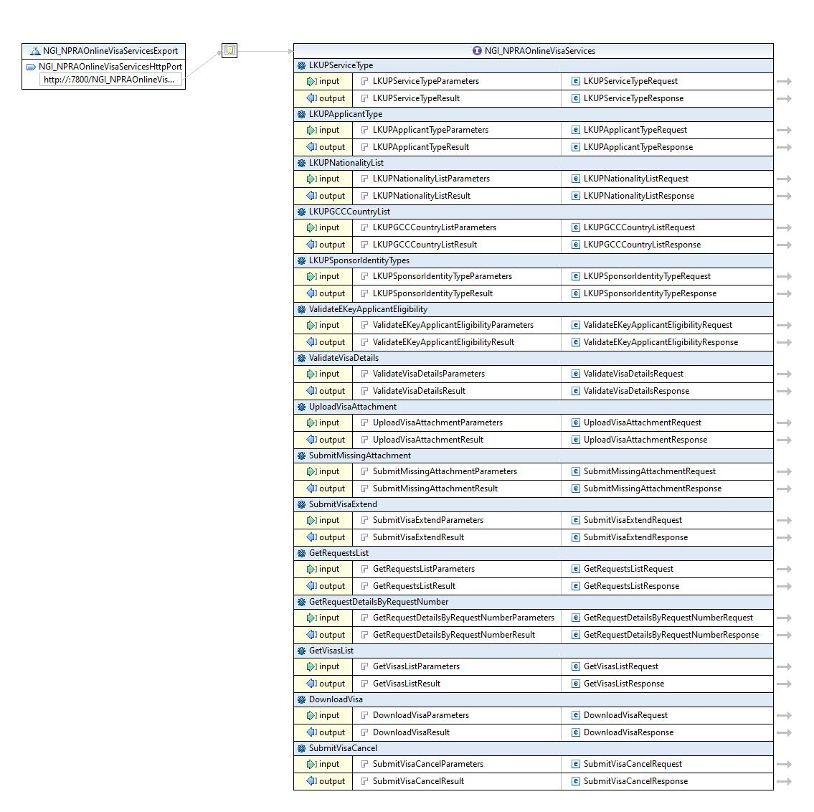

Technical Properties

LKUPServiceType
Service Id | NGI_NPRAOnlineVisaServices
Operation Id | LKUPServiceType
Operation | LKUPServiceType
Input Msg | 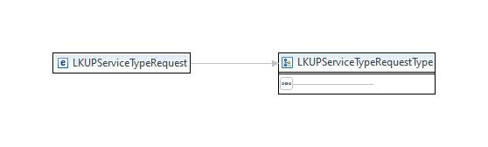
Output Msg | 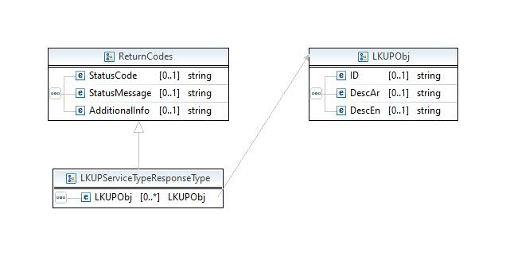
Exception (Fault) | Default SOAP/ SOAP12 fault message will be generated

LKUPApplicantType
Service Id | NGI_NPRAOnlineVisaServices
Operation Id | LKUPApplicantType
Operation | LKUPApplicantType
Input Msg | 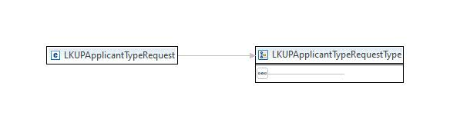
Output Msg | 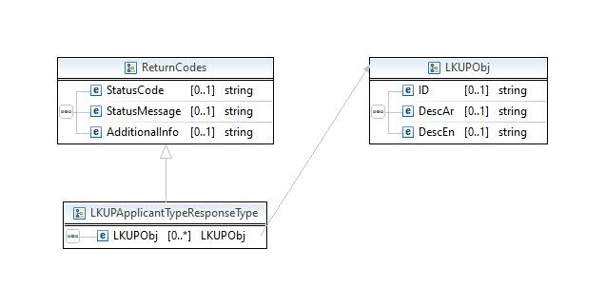
Exception (Fault) | Default SOAP/ SOAP12 fault message will be generated

LKUPNationalityList
Service Id | NGI_NPRAOnlineVisaServices
Operation Id | LKUPNationalityList
Operation | LKUPNationalityList
Input Msg | 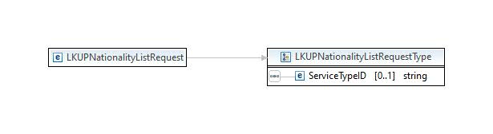
Output Msg | 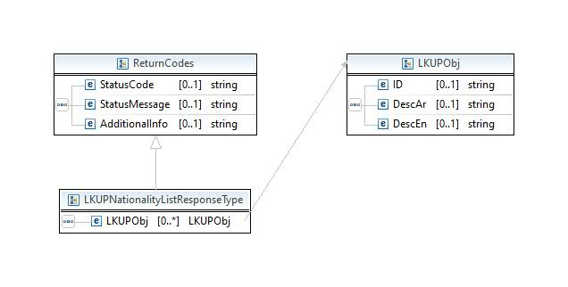
Exception (Fault) | Default SOAP/ SOAP12 fault message will be generated

LKUPGCCCountryList
Service Id | NGI_NPRAOnlineVisaServices
Operation Id | LKUPGCCCountryList
Operation | LKUPGCCCountryList
Input Msg | 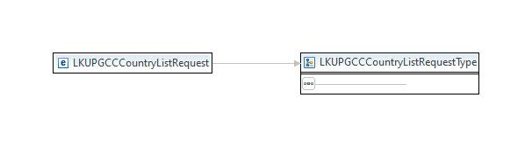
Output Msg | 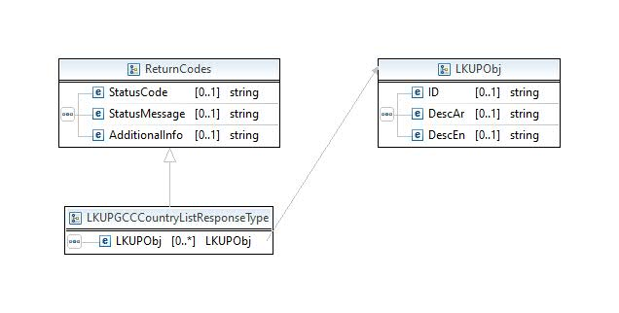
Exception (Fault) | Default SOAP/ SOAP12 fault message will be generated

LKUPSponsorIdentityTypes
Service Id | NGI_NPRAOnlineVisaServices
Operation Id | LKUPSponsorIdentityTypes
Operation | LKUPSponsorIdentityTypes
Input Msg | 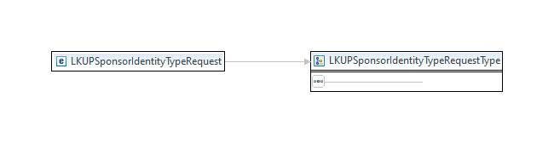
Output Msg | 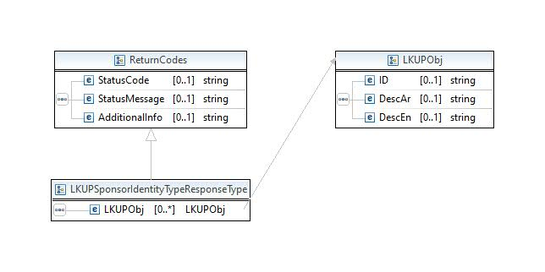
Exception (Fault) | Default SOAP/ SOAP12 fault message will be generated

ValidateEKeyApplicantEligibility
Service Id | NGI_NPRAOnlineVisaServices
Operation Id | ValidateEKeyApplicantEligibility
Operation | ValidateEKeyApplicantEligibility
Input Msg | 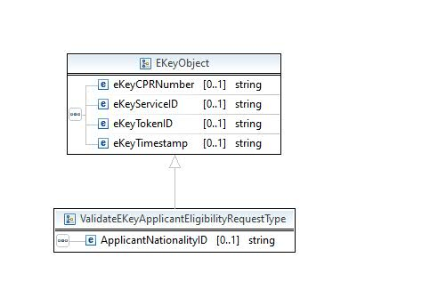
Output Msg | 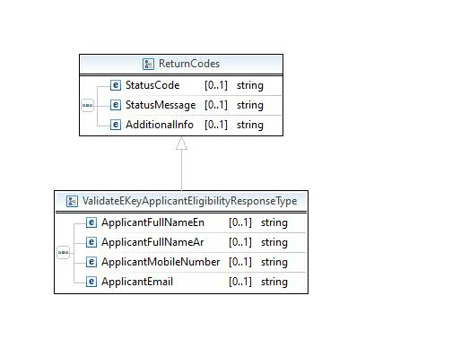
Exception (Fault) | Default SOAP/ SOAP12 fault message will be generated

ValidateVisaDetails
Service Id | NGI_NPRAOnlineVisaServices
Operation Id | ValidateVisaDetails
Operation | ValidateVisaDetails
Input Msg | 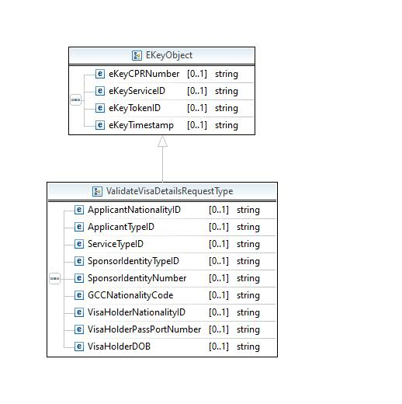
Output Msg | 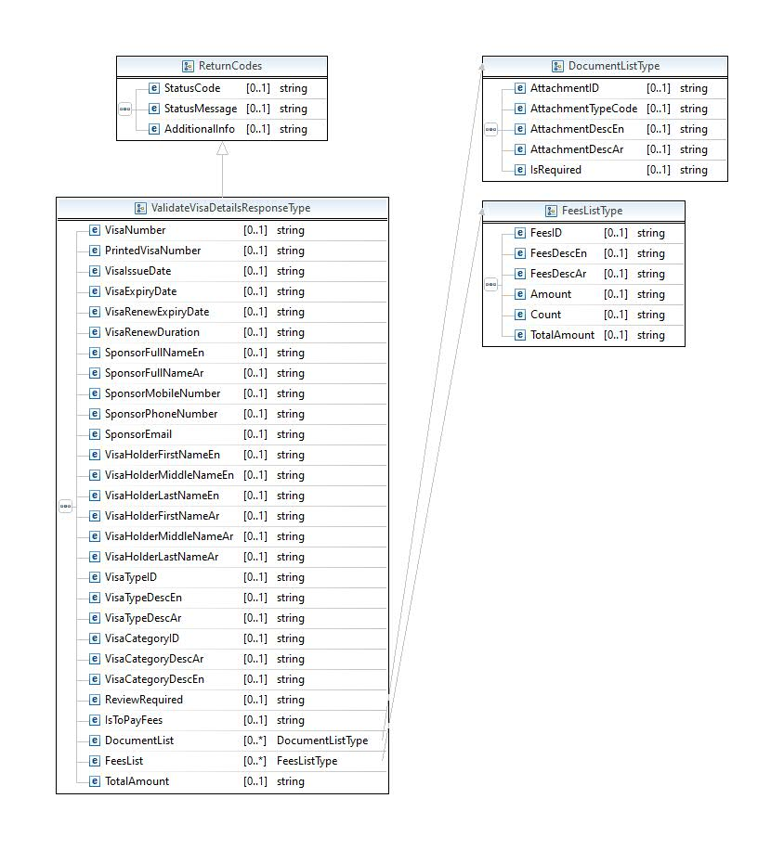
Exception (Fault) | Default SOAP/ SOAP12 fault message will be generated

UploadVisaAttachment
Service Id | NGI_NPRAOnlineVisaServices
Operation Id | UploadVisaAttachment
Operation | UploadVisaAttachment
Input Msg | 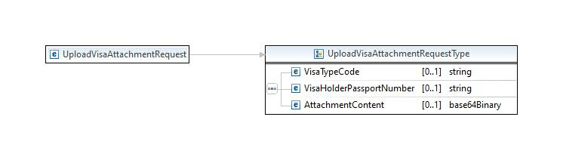
Output Msg | 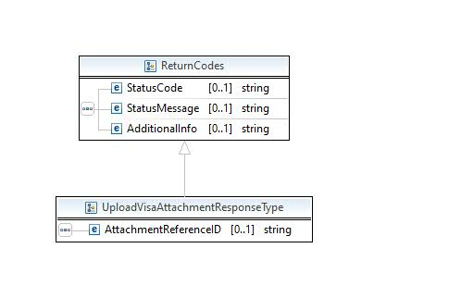
Exception (Fault) | Default SOAP/ SOAP12 fault message will be generated

SubmitVisaExtend
Service Id | NGI_NPRAOnlineVisaServices
Operation Id | SubmitVisaExtend
Operation | SubmitVisaExtend
Input Msg | 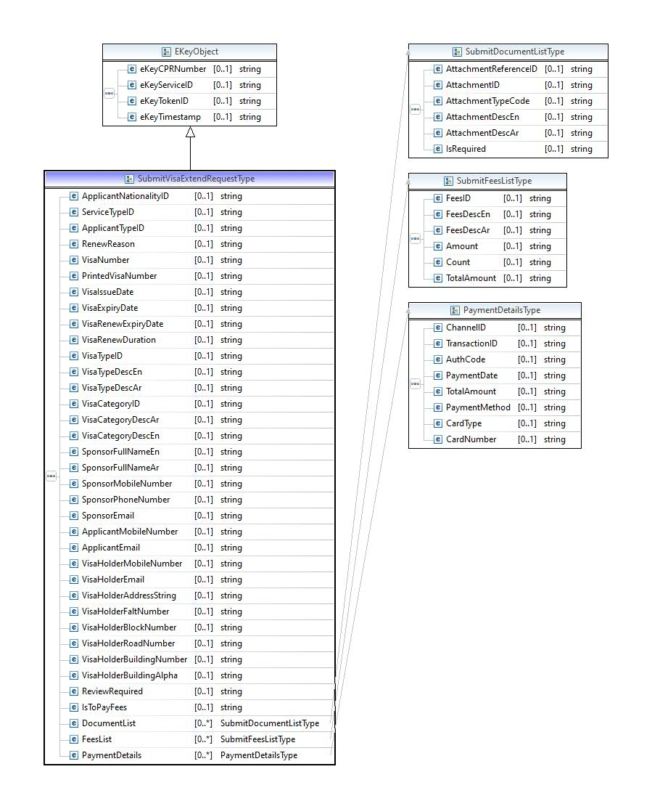
Output Msg | 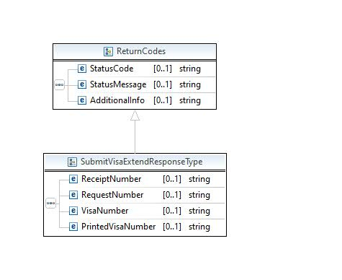
Exception (Fault) | Default SOAP/ SOAP12 fault message will be generated
NGI Comments

GetRequestsList
Service Id | NGI_NPRAOnlineVisaServices
Operation Id | GetRequestsList
Operation | GetRequestsList
Input Msg | 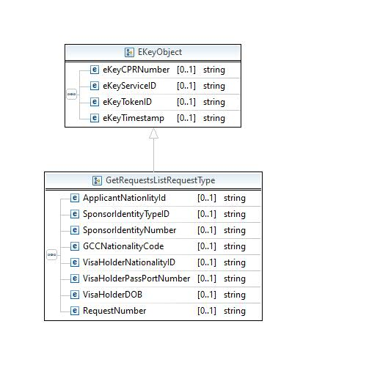
Output Msg | 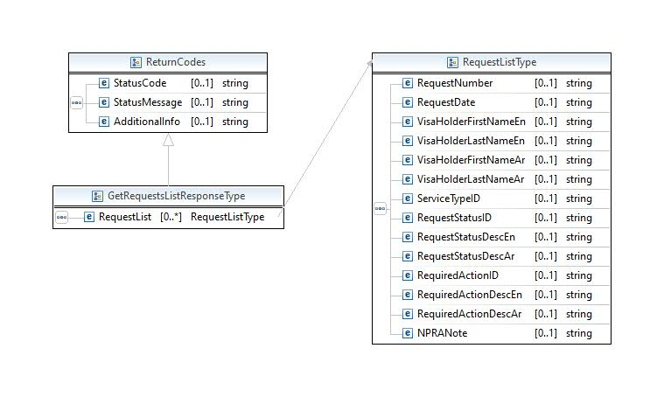
Exception (Fault) | Default SOAP/ SOAP12 fault message will be generated
NGI Comments

GetRequestDetailsByRequestNumber
Service Id | NGI_NPRAOnlineVisaServices
Operation Id | GetRequestDetailsByRequestNumber
Operation | GetRequestDetailsByRequestNumber
Input Msg | 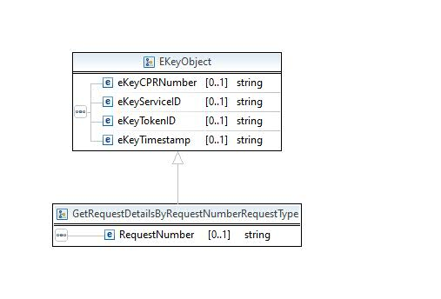
Output Msg | 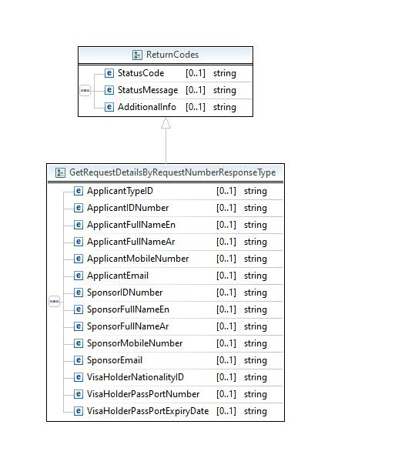
Exception (Fault) | Default SOAP/ SOAP12 fault message will be generated
NGI Comments

GetVisasList
Service Id | NGI_NPRAOnlineVisaServices
Operation Id | GetVisasList
Operation | GetVisasList
Input Msg | 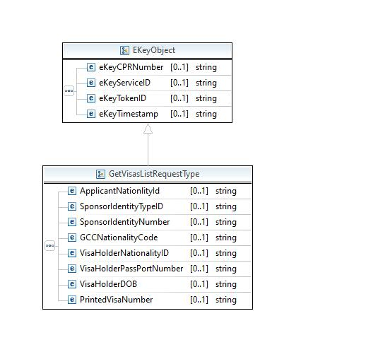
Output Msg | 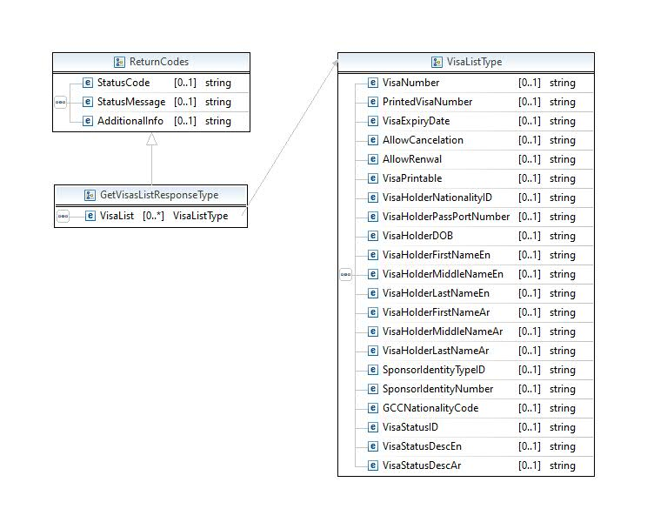
Exception (Fault) | Default SOAP/ SOAP12 fault message will be generated
NGI Comments

DownloadVisa
Service Id | NGI_NPRAOnlineVisaServices
Operation Id | DownloadVisa
Operation | DownloadVisa
Input Msg | 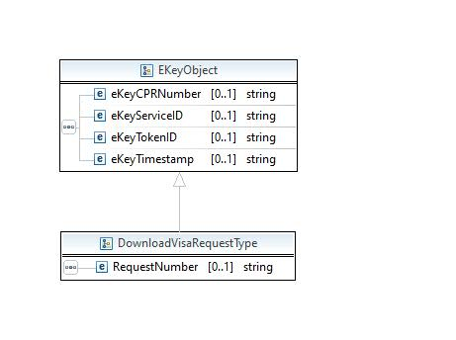
Output Msg | 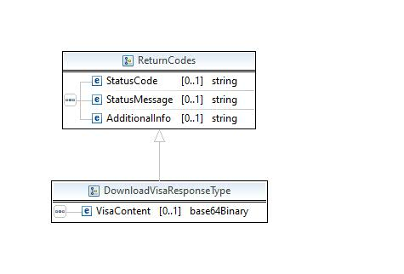
Exception (Fault) | Default SOAP/ SOAP12 fault message will be generated
NGI Comments

Business Flow Usage
NA

Message Definition

Find the WSDLfile below.

Error Code and Error Message
Find the below Status Codes and Status Messages
NPRA Error Codes | NPRA Error Messages | NGI STATUS CODE | NGI STATUS MESSAGES | NGI Method
000 | Success | NPRAOVR-0000 |  | Generic for All Operations
 |  | NPRAOVR-0001 | FAILURE, EXCEPTION INVOKING BACKEND | Generic for All Operations
 |  | NPRAOVR-0005 | FAILURE, UNCHECKED EXCEPTION | Generic for All Operations
001 | General Backend exception occured. | NPRAOVR-0011 | NPRA-General Backend exception occured. | Generic for All Operations
002 | Authentication failed | NPRAOVR-0012 | Authentication failed | Generic for All Operations
003 | Person age not matched | NPRAOVR-0013 | Person age not matched | Generic for All Operations
004 | Person is dead | NPRAOVR-0014 | Person is dead | Generic for All Operations
005 | Person not found | NPRAOVR-0015 | Person not found | Generic for All Operations
006 | Invalid parameter | NPRAOVR-0016 | Invalid parameter | Generic for All Operations
007 | No visa exist for this passport. | NPRAOVR-0017 | No visa exist for this passport. | Generic for All Operations
008 | Person passport is replaced with new passport. | NPRAOVR-0018 | Person passport is replaced with new passport. | Generic for All Operations
009 | Person is outside of Bahrain. | NPRAOVR-0019 | Person is outside of Bahrain. | Generic for All Operations
010 | Person passport is expired. | NPRAOVR-0020 | Person passport is expired. | Generic for All Operations
011 | Person passport status is not valid or passport replaced. | NPRAOVR-0021 | Person passport status is not valid or passport replaced. | Generic for All Operations
012 | Person passport is reported as lost passport. | NPRAOVR-0022 | Person passport is reported as lost passport. | Generic for All Operations
013 | Person passport is reported as watch list. | NPRAOVR-0023 | Person passport is reported as watch list. | Generic for All Operations
014 | Person last arrival date is more than 6 months. | NPRAOVR-0024 | Person last arrival date is more than 6 months. | Generic for All Operations
015 | Visa is not extendable. | NPRAOVR-0025 | Visa is not extendable. | Generic for All Operations
016 | Visa exceeds the allowed count for extensions. | NPRAOVR-0026 | Visa exceeds the allowed count for extensions. | Generic for All Operations
017 | Visa is not used before for entry to Bahrain. | NPRAOVR-0027 | Visa is not used before for entry to Bahrain. | Generic for All Operations
018 | Visa is cancelled. | NPRAOVR-0028 | Visa is cancelled. | Generic for All Operations
019 | Applicant person CPR is required. | NPRAOVR-0029 | Applicant person CPR is required. | Generic for All Operations
020 | Applicant person is dead. | NPRAOVR-0030 | Applicant person is dead. | Generic for All Operations
021 | Applicant person is watch listed. | NPRAOVR-0031 | Applicant person is watch listed. | Generic for All Operations
022 | Applicant person age is not legal to apply request. | NPRAOVR-0032 | Applicant person age is not legal to apply request. | Generic for All Operations
023 | Sponsor is not exist. | NPRAOVR-0033 | Sponsor is not exist. | Generic for All Operations
024 | Sponsor is different from visa sponsor. | NPRAOVR-0034 | Sponsor is different from visa sponsor. | Generic for All Operations
025 | Sponsor person is dead. | NPRAOVR-0035 | Sponsor person is dead. | Generic for All Operations
026 | Sponsor country is required for GCC sponsor. | NPRAOVR-0036 | Sponsor country is required for GCC sponsor. | Generic for All Operations
027 | Sponsor transactions are suspended. | NPRAOVR-0037 | Sponsor transactions are suspended. | Generic for All Operations
028 | Sponsor is watch listed. | NPRAOVR-0038 | Sponsor is watch listed. | Generic for All Operations
029 | Visa type doesn't has defined fees for extend. | NPRAOVR-0039 | Visa type doesn't has defined fees for extend. | Generic for All Operations
030 | Visa type doesn't has defined fees for delay. | NPRAOVR-0040 | Visa type doesn't has defined fees for delay. | Generic for All Operations
031 | Extend fees are not calculated correctly. | NPRAOVR-0041 | Extend fees are not calculated correctly. | Generic for All Operations
041 | Paid amount is not equal to the required amount to be paid. | NPRAOVR-0042 | Paid amount is not equal to the required amount to be paid. | Generic for All Operations
042 | Required visa is not exist. | NPRAOVR-0043 | Required visa is not exist. | Generic for All Operations
043 | Applicant person in not exist. | NPRAOVR-0044 | Applicant person in not exist. | Generic for All Operations

Security

Standard WS security features will be used to secure the service. Please use the below security headers based on the end point either SOAP1.1 or SOAP1.2

Sample SOAP1.1 Header
<soapenv:Header>
<wsse:Security soapenv:actor="ngi" mustUnderstand="1" xmlns:wsse="http://docs.oasis-open.org/wss/2004/01/oasis-200401-wss-wssecurity-secext-1.0.xsd">
<wsse:UsernameToken>
<wsse:Username wsu:Id="unt_907818524" xmlns:wsu="http://docs.oasis-open.org/wss/2004/01/oasis-200401-wss-wssecurity-utility-1.0.xsd">username</wsse:Username>
<wsse:Password Type="http://docs.oasis-open.org/wss/2004/01/oasis-200401-wss-username-token-profile-1.0#PasswordText">password</wsse:Password>
</wsse:UsernameToken>
</wsse:Security>
</soapenv:Header>

